WHAT DOES “THINK GLOBAL ACT LOCAL” MEAN FOR THIS PROJECT?

What does “Think Global, Act Local” mean?
The phrase “Think Global, Act Local” is so widely used because of its wide application. It is easy to understand as well as an empowering way to handle many global issues that are very relevant to our times.

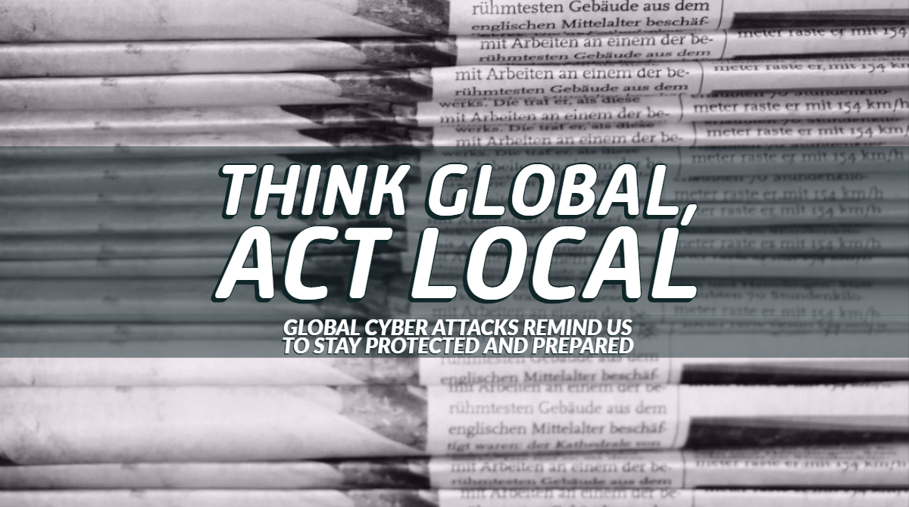
The concept – “Think Global, Act Local” was derived from the book written in the year 1915 by Patrick Geddes, a social activist, and a town planner. He stated that town planning should be done while keeping the environment in mind. So, from them, environmentalists reiterate the concept by saying that while taking any action, the whole health of the planet should be kept in mind, because local actions c ause a significant impact on the world.
However, with time, the phrase has gained many interpretations and has been used in a lot of sectors like the environment, businesses, education, food consumption, politics, art, etc.
<\Page break>
In Environment:
The phrase embodies the idea that instead of waiting for grand breakthroughs to “fix the world”, we should implement environmentally conscious solutions into everyday decisions and actions. Though on their own it seems to have negligible impact, in aggregate, these can have a globally transformative effect.
In Businesses:
Multinational companies expand their products and services to other countries. However, if they do not take local needs into account, they may fail because people may not relate to their products. So, the MNCs do their research about the local needs and culture, they modify their services to suit local needs while maintaining consistency with the local brand.
In Education:
To put it simply, it means: Be open-minded about learning about issues, cultures, and events around the world, and make use of this knowledge to improve your local area, hometown, or country.
<\Page Break>
Suffice to say, this slogan has stood for various causes over time. Such several interpretations of this quote create a need to explain how this project understands its meaning:
When we hear and watch global news headlines, we often tune it out. “It’s not happening here; it’s not affecting us directly”. But by the time it hits home, we do not know what it is about and become victims to the global calamity.
“Think Global” means to be aware of the problems and dangers across the globe and find ways to solve them or prevent them in our home or locality. “Act Local” means to implement these precautions to solve global problems that might affect your home and locality one day too.
One such global problem that people are less aware of, while also being increasingly more prominent with time in this digital world is Cyberthreats. And hence this project focuses on Cybersecurity.
<\Page Break>

WHAT IS CYBERSECURITY?

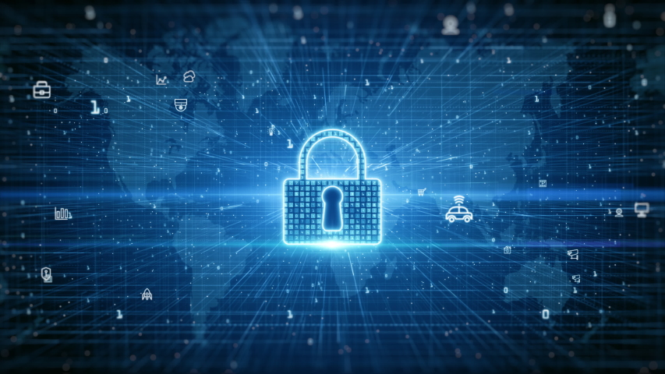
What is a Cyberthreat?

A Cyberthreat or Cybersecurity threat is a malicious act that seeks to damage data, steal data, or disrupt digital life in general. Cyber threats include computer viruses, data breaches, Denial of Service (DoS) attacks, and other attack vectors.
Cyber threats also refer to the possibility of a successful cyber-attack that aims to gain unauthorized access, damage, disrupt, or steal an information technology asset, computer network, intellectual property, or any other form of sensitive data.
They can originate from various sources, including corporate spies, hacktivists, terrorist groups, hostile nation-states, criminal organizations, lone hackers, and disgruntled employees.
In recent years, numerous high-profile cyber-attacks have resulted in sensitive data being exposed. And in most cases, the cyber threats are enabled by the individual or organization’s failure to implement, test, and retest technical safeguards, such as encryption, authentication, and firewalls.
Cyber attackers can use an individual’s or a company’s sensitive data to steal information or gain access to their financial accounts, among other potentially damaging actions, which is why cyber security professionals are essential for keeping private data protected.
<\Page Break>
What is Cybersecurity?

Cybersecurity is the protection of internet-connected systems such as hardware, software, and data from cyber threats. The practice is used by individuals and enterprises to protect against unauthorized access to data centers and other computerized systems.
A strong Cybersecurity strategy can provide a good security posture against malicious attacks designed to access, alter, delete, destroy or extort an organization's or user's systems and sensitive data. Cybersecurity is also instrumental in preventing attacks that aim to disable or disrupt a system's or device's operations.

The Cybersecurity field can be broken down into several different sections. These sections include the following
- Application security
- Information or data security
- Network security
- Disaster recovery
- Cloud security
- Critical infrastructure security
- Physical security
<\Page Break>
Why is Cybersecurity important to be aware of?

- There are roughly 4,000 cyberattacks every day and the rate of Cybercrime continues to rise every day. The main reason for this is that it is cheap, fast, and highly profitable compared to other types of crime.
- A cyberattack can cost organizations millions of dollars in damage, but it's not just the financial damage. It is also very damaging to the reputation of these organizations. It gravely impacts their ability to do business and sometimes even compromises the health of employees, patients, customers, and others
- Cyberattacks have a huge impact on the trust that the customers and employees of an organization place in it. When people feel that their information is not secure and private, they begin to lose trust in the brand, its product, and its services.
- Our identities protect our data: User identities now protect millions of points of data. This is the data that we’re transmitting at work, data from internet of things devices like a coffee maker, the printers we use, and our personal information as well. As more of our data is becoming digitalized, securing these identities helps to reduce the risk of Cyberattacks on organizations and individuals alike.
<\Page Break>

DATA BREACHES IN LARGE ORGANIZATIONS
Every organization has Vulnerabilities. As organizations evolve, merge and grow over time, their networks and systems naturally get more complicated, which leads to more vulnerabilities that could be taken advantage of by Cyber Criminals. Additionally, end-users like us are often the weakest link in an organization's security. To prevent this an organization needs to put robust security and compliance protection in place.
Despite all these measures, some hackers do manage to steal data from these organizations. Some major data breaches in the past decade are:


- Yahoo data breaches (3 billion accounts)
Yahoo one of the biggest service providers out there has been a victim of many cyber-attacks leading to very large data breaches. Some examples of this are:
- The August 2013 breach was revealed to the general public by yahoo in December 2016.
  - The data of all its 3 billion accounts at the time of august 2013 had been compromised.
  - Details like account names, email addresses, telephone numbers, hashed passwords, and security questions and answers had been leaked in this data breach.
  - This breach is now considered to be the largest data breach of its kind.
- The second major data breach happened in late 2014.
  - Similar information as the 2013 breach was compromised from 500 million users.
  - According to security experts, the data obtained could be used to hack other accounts containing personal information related to the users.
- Around July 2016 data from almost 200 million accounts was presented for sale on the darknet.
  - The seller said in confidential interviews that he had been Selling the data since 2015.
  - Yahoo said that they were aware of the breach and they were evaluating the data but they did not reset account passwords at that time.
<\Page Break>
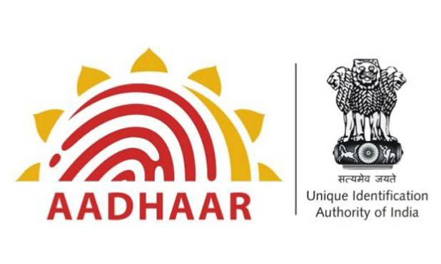
- Aadhaar data leak 2018 (1.1 billion people)
Aadhaar is a unique identification number that is based on the biometric and demographic data of the person and is used by over 1.1 billion residents of India.
- In early 2018 it was reported that the identification database Aadhar was leaking data on every registered Indian citizen.
  - The leaked data included names, bank details, and even biometric data along with various other private information.
- Another leak was identified in the following months where a state-owned utility company Indane, due to its unprotected system, allowed anyone to access private information on Aadhaar holders.
- Also, Aadhaar information of over 130 million citizens was breached through over 200 government websites as the data was made public through them due to an error.
- The Aadhaar data breach was deemed the largest data breach in the world by the WEF Global Risk Report.
<\Page Break>

- Facebook data breach 2019 (533 million users)
- In April 2021 it was revealed that the data of over 533 million Facebook users from 106 different countries were available to download for free online.
  - The exposed data contained information such as phone numbers, location, full name, dob, and in some cases email addresses.
- Facebook said that the data was lifted due to a vulnerability that was patched in August 2019.
- Facebook said that the information leaked did not include financial and health information and did not include passwords as well.
<\Page Break>
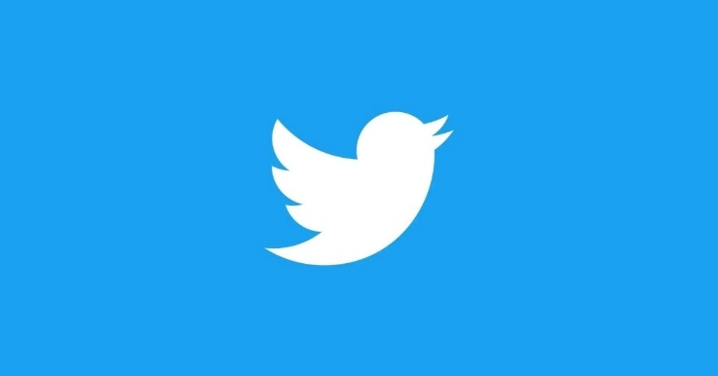
- Twitter bug 2018 (330 million users)
- In May 2018 Twitter revealed that they had discovered a bug where account passwords were being stored to an internal log before they could be hashed.
- Twitter said in a statement that they had fixed the bug and asked their 330 million users at the time to consider changing their password on all services where the same password had been used as a precaution.
<\Page Break>

- Uber data breach 2016 (57 million users,600k drivers)
- Uber CEO Dara Khosrowshahi revealed in November 2017 that there had been a breach in late 2016 and the personal details of 57 million users including 600k drivers were compromised.
- The breached data included names, email addresses, and phone numbers of its users as well as its drivers. Along with this, the license numbers of its drivers were also compromised.
- Instead of reporting the breach, Uber paid the hackers 100k to delete the data and keep quiet about the breach.
- Uber agreed to pay 148 million dollars in connection with the breach and to settle claims over the company's subsequent cover-up.

We can see that even such organizations that invest a large amount of their capital into cybersecurity are not invulnerable to cyberattacks. Thus, we should be cautious when handling our data.
<\Till now completed to write>

SURVEY QUESTIONS AND RESULTS
To understand the mentality of people when it comes to cybersecurity, a survey was conducted. The participants of the survey are anonymous. The questions asked were designed to analyze how secure a participant’s data is and compare it to the methods used by hackers in some well-known cyber-attacks that have affected celebrities and major organizations.
The survey was made with the help of google forms and distributed across social platforms like Reddit, YouTube, and Instagram.
A copy of the survey along with our analysis of the result is followed.
<\Page Break>
- How often do you update your passwords?
  - Never
  - Once every two years
  - Once a year
  - Twice a year
  - More than twice a year
- Do you use the same password for many sites?
  - Yes b. No
- What sort of passwords do you use?
  - Alphabets, numbers, and symbols
  - Alphabets and numbers
  - Alphabets
  - Common passwords like “password” or “1234” or your DOB or a family member’s name
- How many people do you share your device password with?
  - No one b. 1 c. 2 d. More
- What is your preferred method of logging in?
  - Login with Google
  - Login with Facebook
  - Login with some other big site
  - Creating a username and password
- How do you keep your passwords?
  - Password managers
  - Remember your passwords
  - Writing it down in a notebook
  - Writing it down on electronic devices
- Do you know anyone who has been affected by any cyberattack?
  - Yes b. No

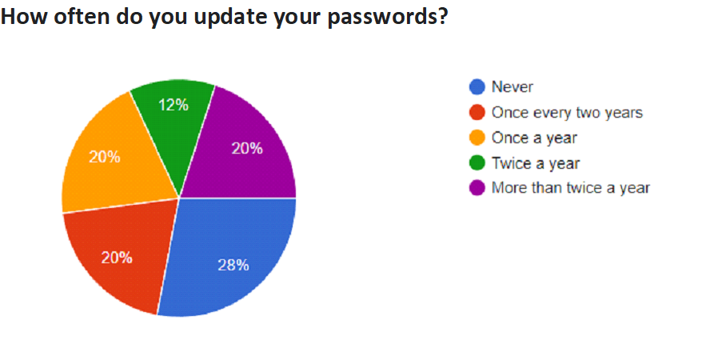

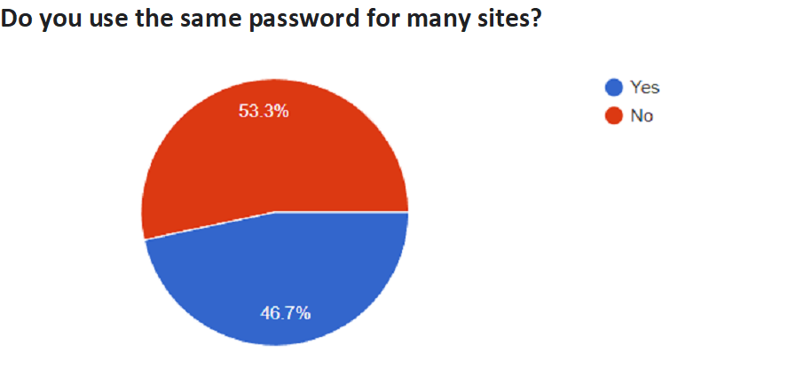

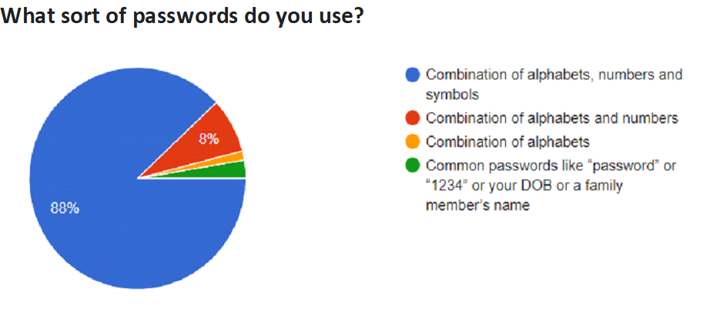

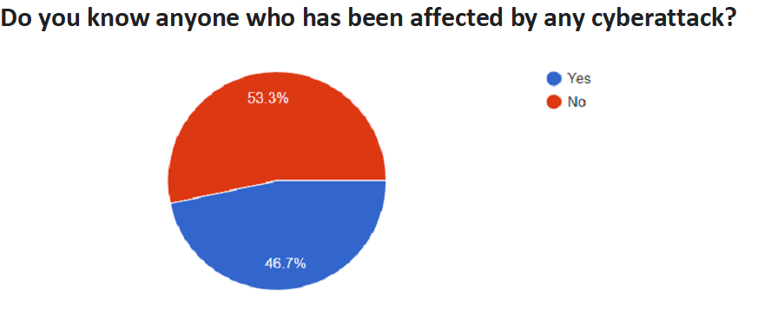

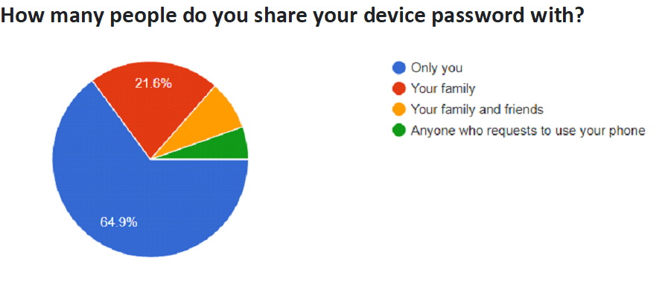

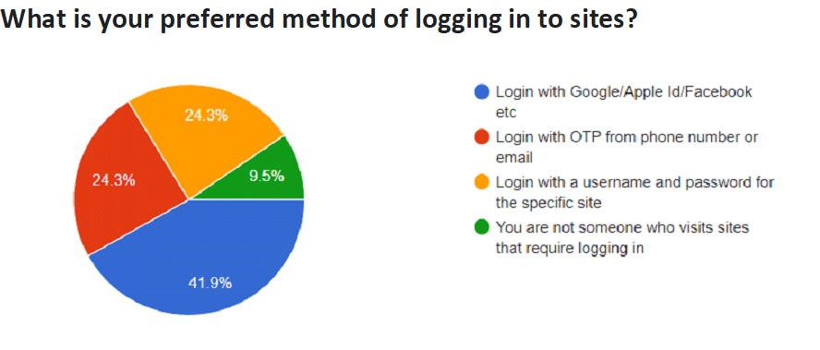

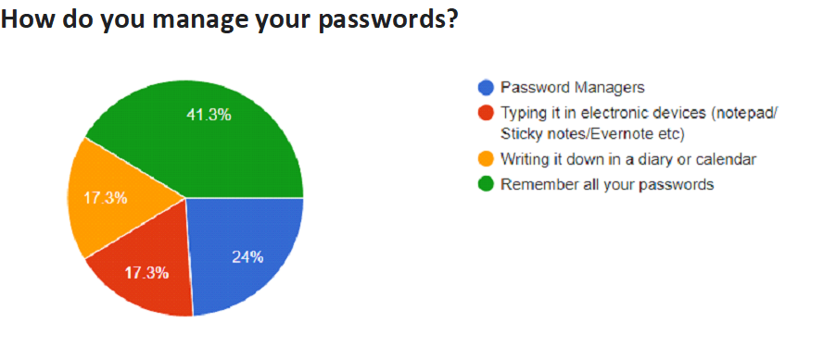

SURVEY ANALYSIS



People should at least change their passwords once every year for the ones that are used for less important stuff and at least once every 6 months for the important passwords.
Looking at the data only 52% of respondents change their passwords at least once a year and just 32% of the respondents do it twice a year or more.
WHY SHOULD YOU UPDATE YOUR PASSWORDS?
- Prevents constant access
- Prevents use of saved passwords
WHEN SHOULD YOU UPDATE YOUR PASSWORDS?
- After a security breach
- If you suspect unauthorized access
- If you discover malware or other phishing software
- Shared access of your account to someone
- If you have Logged in at public places
- If you haven’t logged in for a while
<\Page Break>



47% of the respondents use the same password for many sites.
This is extremely dangerous because if any one of the websites or services that the users use is compromised, the same password can be used to steal data from the other websites as well.
In June 2016, the CEO of Facebook, Mark Zuckerberg suffered identity theft and had his Twitter, Instagram, and Pinterest accounts hacked.

    - The single driving reason as to why accounts across his social networks were hacked is the fact that Zuckerberg was using the same password for all of his social accounts.
    - A cybercriminal group known by the name “OurMine” were the ones behind the hack.
    - In 2012 these hackers managed to get 117 million passwords from the LinkedIn professional network, among them, the creator of Facebook’s credentials as well.
    - And apparently, Zuckerberg had the same password for his other accounts which led to the hackers gaining access to his Twitter, Instagram, and Pinterest accounts.
<\Page Break>



One of the main problems with having a weak password is that it makes it easier for attackers to steal your data.
    - A common way for attackers to access passwords is by brute-forcing or cracking passwords. These methods use software or automated tools to generate billions of passwords and try each one of them to access the user’s account and data until the right password is discovered.
    - If the user’s password is not strong and complex it can be easily compromised through the above method; therefore, it is necessary to have strong and complex passwords to make it as difficult as possible for an attacker to obtain the password.
<\Page Break>
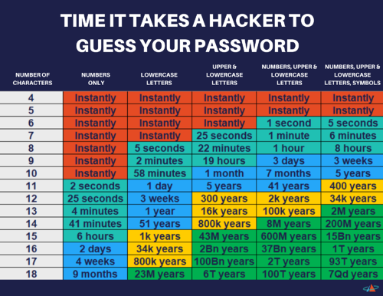

Another problem of having a weak and obvious password is that good hackers know the general formulas people use for passwords.
    - If the user uses his birthdate, phone number, or even a pet name, a good hacker will easily compromise the passwords; this is because accomplished hackers are aware of what people generally do when making simple passwords.

One disastrous cyber-attack case due to the passwords being weak was the “Fappening”.
    - In 2014 there was a massive leak of intimate photographs of famous people that was called the Fappening movement or “Celeb Gate”.
    - The hackers used a script developed in Python called iBRUTE. It is a type of ‘Brute Force’ attack, with which the key of an account can be deciphered by repetitive attempts until it is revealed.
    - This is one of the reasons how hackers managed to get the data of celebrities.
<\Page Break>



42% of the respondents log in with their google Id, Facebook Id, etc.
This should also be avoided as far as possible because if your Google/Facebook/Apple Id you use is compromised the data from all the websites on which you used google login can be easily stolen.
24.3% of the respondents log in through a specific username and password for the site and another 24.3% log in through an OTP (One-Time Password) from their mobile number or email. These two methods should be used for logging into other websites as far as possible with the second method (OTP) being the best.
    - By using a specific username and password for every site you use we are limiting the scope of what a hacker can do with our data if one of the sites is hacked.
    - By using a One-Time password, we are eliminating most of the risks that come online as the password is only valuable for that one instance of login; after that it becomes unusable. Hence this method should be preferred for logging into sites as far as possible.
The dangers of this can be seen using the aforementioned Fappening movement or “Celeb Gate”
    - The attack was perpetrated through a vulnerability in Apple’s “Find my iPhone” application that connects to the user’s ID.
    - This vulnerability in Apple allowed hackers to make multiple attempts at guessing passwords without getting blocked.
    - Due to most of the passwords being weak along with the fact that iCloud did not take the precaution of blocking the accounts in which logins with repetitive attempts were made, this became a massive attack. So, it is necessary we make sure to trust the organization before we use it to access other websites
<\Page Break>



As we can see 65% of all respondents do not share their device passwords with anyone.
This should be practiced as far as possible. Although there can be a few exceptions for family or friends to completely trust, it is still generally advised to not share your device password with anyone.
5% of the respondents share their passwords with anyone and everyone.
    - This is an extremely dangerous practice as it basically creates more windows for attackers to steal your sensitive information from i.e., they have a greater number of sources to get the said information from. Therefore, you are making it way easier for someone to access your data and steal it. Doing this should be avoided at any cost.
<\Page Break>



As we can see 41.3% of respondents remember all their passwords.
This is arguably the best method to manage your passwords. By doing this you are essentially eliminating all risks of your password being stolen through any other method than a cyber-attack.
24% of respondents use a password manager which is a good method overall but you should be very careful about which password manager you use.
    - You should only ever use trusted and branded password managers.
    - You should never use any password managers that seem suspicious to you or are of poor quality.
17.3% of respondents write down their passwords in some form of paper and another 17.3% of respondents type it down in notepad etc.
    - This should be avoided as far as possible.
    - If anyone gets access to the diary in which you have written down your passwords, they will easily be able to steal data from all the websites where the passwords are used.
    - A lot of people store their passwords in plain text in excel, notepad, etc. And the shocking thing is that almost 40% of all organizations store their passwords in a plain readable format in spreadsheets. This is a huge risk; if anyone gets unauthorized access to or hijacks the user’s/organizations systems they can easily steal the passwords. In fact, stealing passwords couldn’t be easier than this.
<\Page Break>



As we can see 47% of people know other people who have been affected by cyber-attacks.
This just goes to show how widespread cyber-attacks are and that the people are not educated on the topic of cyber threats and cyber security. More people should be made aware of cyber security and that cyber security is an integral part of everyday life.
A famous person who fell victim to a cyber-attack due to a lack of awareness regarding cyber security and cyber threats is the TV Journalist Nidhi Razdan.


      - She claimed in January 2021 that she had been the victim of a very serious phishing attack in which she was offered the post of “Associate Professor of Journalism” at the prestigious Harvard University in the United State.
      - She made the grave mistake of not confirming the offer with the authorities at the university which is what lead to her falling prey to the attack.
      - In a tweet on Twitter, she said that she was made to believe that she would be joining the University in September 2020, but citing the Covid pandemic was told that her classes were to begin from January.
      - She began noticing a lot of administrative anomalies in the process being described to her, but she dismissed the “anomalies” thinking of them as part of the “new normal dictated by the pandemic”.
      - Later as the number of anomalies kept increasing, she contacted the superior authorities of the University and found out that the offer letter was fraudulent.

Most of the cyberattacks on common everyday people are done through the following methods:
- Sending Malware
- Phishing attacks
<\Page Break>
MALWARE

The term “Malware” refers to malicious code or harmful software that disrupts and manipulates a system. The mentioned system can be a PC, a phone, an iOS device, etc.
Malware typically infects a system by tricking users into clicking/ downloading something that they shouldn’t from the internet. When this occurs, the malware performs actions that the user didn’t intend such as:
          - Slowing down a system considerably.
          - Bombarding a browser with ads.
          - rendering essential system functions inoperable thus making the system inoperable.
          - Sometimes even blocks access to the system completely and forces the user to make a payment in order to gain back access.
There are different types of Malwares out there and they can be selectively used depending on what the attacker wants to do:
          - A computer virus that is designed to reproduce itself and spread from one file/program to another.
          - Trojan horses appear as harmless programs but when activated they damage their host system. Trojan horses do not replicate and are usually used to steal passwords and other key data from the system
          - Spyware that infects a system and operates on it to monitor what someone is doing on their system.
          - Worms replicate themselves and spread through a network. They spread from one network to another as opposed to viruses which spread from file to file.
          - Ransomware is a type of malware that comes with a ransom. It locks and encrypts a user's data and demands a ransom to restore access to the victim.
          - Rootkits are a type of malware that grants the attacker remote control of the target’s device without the knowledge of the target. This type of malware is also capable of avoiding detection from security software's meaning it could stay hidden on the target's device for a long time thereby causing significant damage.
<\Page Break>
PHISHING

Phishing is a type of social engineering attack often used to steal user data, including login credentials and credit card numbers. It occurs when an attacker, pretending as a trusted entity, dupes a victim into opening an email, instant message, or text message. The recipient is then tricked into clicking a malicious link, which can lead to the installation of malware or the revealing of sensitive information
    - On clicking the link, the user might be redirected to a bogus website that is exactly like the real website in appearance. Here the user might be asked to enter sensitive information which is then easily hijacked by the attacker who is monitoring the website.
    - Or the user might be sent to the actual website. However, while being redirected, a malicious script activates in the background to hijack the user’s session cookies, and hence the attacker is able to steal sensitive information. This usually occurs when the website is insecure.
<\Page Break>

WHAT CAN I DO AGAINST CYBERTHREATS?

By using safety measures and good practices to protect your devices, you can protect your privacy and your family.
Keep your device secure
Make sure to download recommended updates from your device's manufacturer or operating system provider, especially for important software such as your internet browser. Antivirus software, anti-spyware software, and firewalls are also important tools to thwart attacks on your device.
Keep up-to-date
Update your system, browser, and important apps regularly, taking advantage of automatic updating when it's available. These updates can eliminate software flaws that allow hackers to view your activity or steal information. Windows Update is a service offered by Microsoft. It will download and install software updates to the Microsoft Windows Operating System, Internet Explorer, Outlook Express, and will also deliver security updates to you. Patching can also be run automatically for other systems, such as Macintosh Operating System. For mobile devices, be sure to install Android or iPhone updates that are distributed automatically.
Antivirus software
Antivirus software protects your device from viruses that can destroy your data, slow down or crash your device, or allow spammers to send email through your account. Antivirus protection scans your files and your incoming email for viruses and then deletes anything malicious. You must keep your antivirus software updated to cope with the latest "bugs" circulating the internet. Most antivirus software includes a feature to download updates automatically when you are online. In addition, make sure that the software is continually running and checking your system for viruses, especially if you are downloading files from the web or checking your email. Set your antivirus software to check for viruses every day. You should also give your system a thorough scan at least twice a month.
Antispyware software
Spyware is software installed without your knowledge or consent that can monitor your online activities and collect personal information while you're online. Some kinds of spyware, called keyloggers, record everything you key in—including your passwords and financial information. Signs that your device may be infected with spyware include a sudden flurry of ads, being taken to websites you don't want to go to, and generally slowed performance.
Spyware protection is included in some antivirus software programs. Check your antivirus software documentation for instructions on how to activate the spyware protection features. You can buy separate antispyware software programs. Keep your antispyware software updated and run it regularly.
To avoid spyware in the first place, download software only from sites you know and trust. Make sure apps you install on a mobile device come from the Apple App Store for iPhones or Google Play for Android devices.
Firewalls
A firewall is a software program or piece of hardware that blocks hackers from entering and using your computer. Hackers search the internet the way some telemarketers automatically dial random phone numbers. They send out pings (calls) to thousands of computers and wait for responses. Firewalls prevent your computer from responding to these random calls. A firewall blocks communications to and from sources you don't permit. This is especially important if you have a high-speed internet connection, like DSL or cable.
Some operating systems have built-in firewalls that may be shipped in the "off" mode. Be sure to turn your firewall on. To be effective, your firewall must be set up properly and updated regularly. Check your online "Help" feature for specific instructions.
Use strong protection
Making use of complex passwords and strong methods of authentication can help keep your personal information secure.
Choose strong passwords
Protect your devices and accounts from intruders by choosing passwords that are hard to guess. Use strong passwords with at least eight characters, a combination of letters, numbers, and special characters. Don't use a word that can easily be found in a dictionary or any reference to personal information, such as a birthday. Some hackers use programs that can try every word in the dictionary and can easily find personal information such as dates of birth. Try using a phrase to help you remember your password, using the first letter of each word in the phrase. For example, HmWc@w2—How much wood could a woodchuck chuck.
Choose unique passwords for each online account you use: financial institution, social media, or email. If you have too many passwords to remember, consider using password manager software, which can help you create strong individual passwords and keep them secure.
Use stronger authentication
Many social media, email, and financial accounts allow the use of stronger authentication methods. These methods can include using a fingerprint, one-time codes sent to a mobile device, or other features that ensure a user is supposed to have access to the account.
Protect your private information
While checking email, visiting websites, posting to social media, or shopping, pay attention to where you click and to whom you give your information. Unscrupulous websites or data thieves can attempt to trick you into giving them your personal data.
Be careful what you click
Phishing attacks—where hackers send seemingly genuine messages to trick you to hand over personal information—are becoming more sophisticated. For instance, you may receive an urgent message stating that your bank account has been locked and requiring you to enter your password and Social Security number to unlock it. Think twice before clicking on links in messages such as this. Most genuine messages from financial institutions will not ask for personal information directly, but will instead instruct you to call or visit a website directly. You can also verify the email address that sent the message to ensure it came from the expected sender.
Shop safely
When shopping online, check out the website before entering your credit card number or other personal information. Read the privacy policy and look for opportunities to opt-out of information sharing. (If there is no privacy policy posted, beware! Shop elsewhere.) Learn how to tell when a website is secure. Look for "https:" in the address bar or an unbroken padlock icon at the bottom of the browser window. These are signs that your information will be encrypted or scrambled, protecting it from hackers as it moves across the internet.
Be careful what you share
Social media allows sharing of all aspects of life, but it's important to control who has access to the information you share. Information thieves can use social media postings to gather information and then use the information to hack into other accounts or for identity theft. To protect yourself, make use of privacy settings to limit the visibility of personal posts to your personal networks, and restrict the amount of information you share with the general public.
Responding to data breaches
Even if you make all the right moves, your data may be stolen from a company you trusted to keep it safe. If you find that your personal information has been accessed without your authorization, take steps to protect yourself. Place a fraud alert on your credit file. Review your annual credit reports. And if you suspect your information has been breached, put a freeze on your credit file to prevent fraudsters from opening new accounts in your name.

BIBLIOGRAPHY

https://www.groupdiscussionideas.com/think-globally-act-locally/
https://riskcenter.wharton.upenn.edu/climate-risk-solutions-2/think-globally-act-locally-think-globally-again/
https://www.techtarget.com/searchsecurity/definition/cybersecurity/
https://onlinedegrees.und.edu/blog/types-of-cyber-security-threats/#:~:text=Cyber%20threats%20can%20originate%20from,in%20sensitive%20data%20being%20exposed./
https://www.upguard.com/blog/cyber-threat/
https://oag.ca.gov/privacy/facts/online-privacy/protect-your-computer/
https://www.proactive-info.com/blog/change-your-password#:~:text=PREVENTS%20CONSTANT%20ACCESS,they%20will%20have%20frequent%20access./
https://www.nationwide.com/lc/resources/personal-finance/articles/how-malware-works#:~:text=How%20does%20malware%20work%3F,shouldn't%20from%20the%20Internet./
https://www.crowdstrike.com/cybersecurity-101/cyberattacks/most-common-cyberattacks/
https://www.cisco.com/c/en-in/products/security/common-cyberattacks.html#~types-of-cyber-attacks/
https://www.imperva.com/learn/application-security/phishing-attack-scam/#:~:text=Phishing%20is%20a%20type%20of,instant%20message%2C%20or%20text%20message./
https://www.cypressdatadefense.com/blog/password-security-risks/
https://www.passcamp.com/blog/dangers-of-storing-and-sharing-passwords-in-plaintext/
https://community.jisc.ac.uk/library/janet-services-documentation/passwords-threats-and-counter-measures/
https://www.npr.org/2018/09/27/652119109/uber-pays-148-million-over-year-long-cover-up-of-data-breach#:~:text=Uber%20is%20paying%20%24148%20million,Uber%20paid%20the%20hackers%20%24100%2C000./
https://www.cnbc.com/2017/11/21/uber-hack-exposes-data-of-57-million-users-and-drivers-report-says.html/
https://www.uber.com/newsroom/2016-data-incident/
https://www.cnbc.com/2018/09/26/uber-to-pay-148-million-for-2016-data-breach-and-cover-up.html/
https://twitter.com/TwitterSupport/status/992132808192634881/
https://www.bbc.com/news/business-43995168/
https://www.upguard.com/blog/biggest-data-breaches/
https://www.theverge.com/2018/5/3/17316684/twitter-password-bug-security-flaw-exposed-change-now/
https://www.businessinsider.in/tech/news/533-million-facebook-users-phone-numbers-and-personal-data-have-been-leaked-online/articleshow/81889315.cms/
https://theconversation.com/facebook-data-breach-what-happened-and-why-its-hard-to-know-if-your-data-was-leaked-158417/
https://en.wikipedia.org/wiki/Yahoo!_data_breaches#:~:text=In%20a%20regulatory%20filing%20in,the%20Internet%20at%20the%20time./
https://en.wikipedia.org/wiki/Data_breaches_in_India/
https://www.moneylife.in/article/aadhaar-data-breach-largest-in-the-world-says-wefs-global-risk-report-and-avast/56384.html/
https://www.csoonline.com/article/2130877/the-biggest-data-breaches-of-the-21st-century.html/
https://www.the420.in/10-celebrities-who-were-recently-attacked-by-the-hackers-on-social-media/
https://www.youtube.com/

